1. Write a program to demonstrate how a JMeter script is recorded. 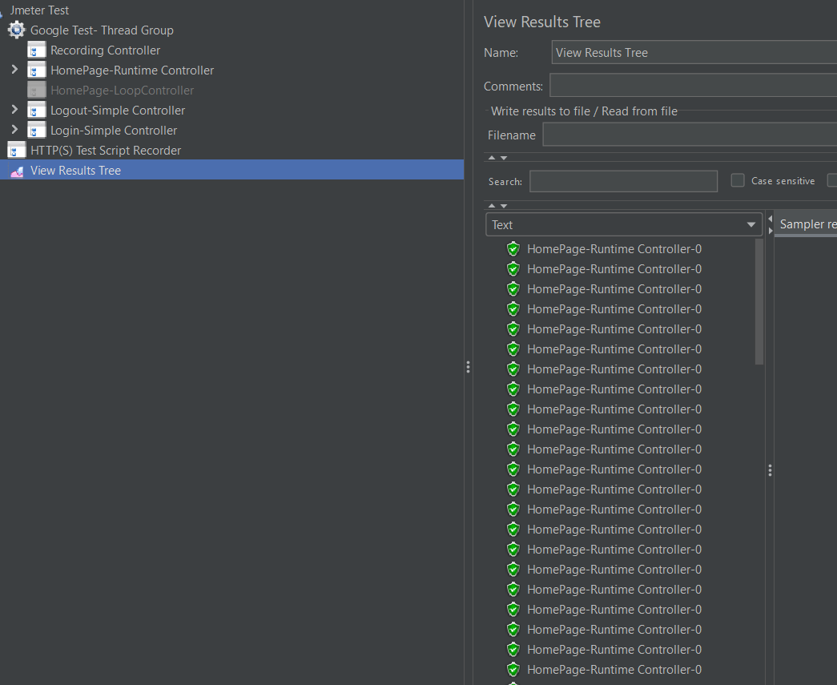
2. Write a program to demonstrate how load (threads) is added in JMeter

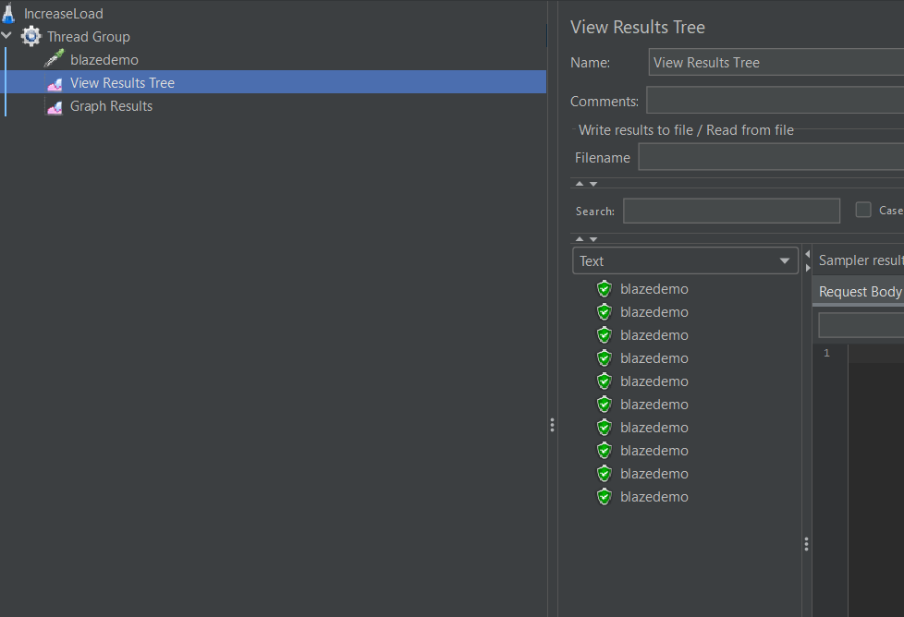

3. Write a program to demonstrate the use of thread group plugin in JMeter.

* To add thread group plugin

**Development Environment:**

* Apache JMeter 5.1.1 Version

This guide has three sub-sections, namely:

1.4.1 Adding thread group plugin

1.4.2 Adding a specific thread group plugin

1.4.3 Pushing the code to GitHub repositories

**Step 1.4.1:** Adding thread group plugin

* Go to any browser and type JMeter plugins manager.
* Click on the link https://jmeter-plugins.org.
* Now, once you click on **Install**, you will get a jar file that will install the plugins.
* The easiest way to get the plugins is to install [the **Plugins Manager**](https://jmeter-plugins.org/wiki/PluginsManager/)[.](https://jmeter-plugins.org/install/)
* Now, [we'll be able to install any other plugin just by clicking a checkbox. Link:-Download](https://jmeter-plugins.org/install/)[plugins-manager.jar](https://jmeter-plugins.org/get/)[and put it into lib/ext directory, then restart JMeter.](https://jmeter-plugins.org/install/)
* 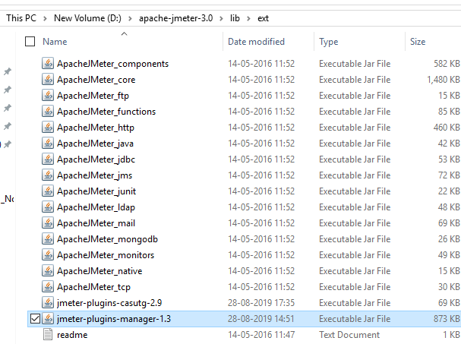

The downloaded plugins_manager.jar file will look like:

**Step 1.4.2:** Adding a specific thread group plugin

* + Open the JMeter tool.
  + Click on the **Options** tab and then click on Plugins Manager.
  + Search for the custom thread group plugin and check the box next to it.
  + Finally, click on **Install** and restart the JMeter tool.

3.Write a program to demonstrate how a SMTP sampler script is run in JMeter.

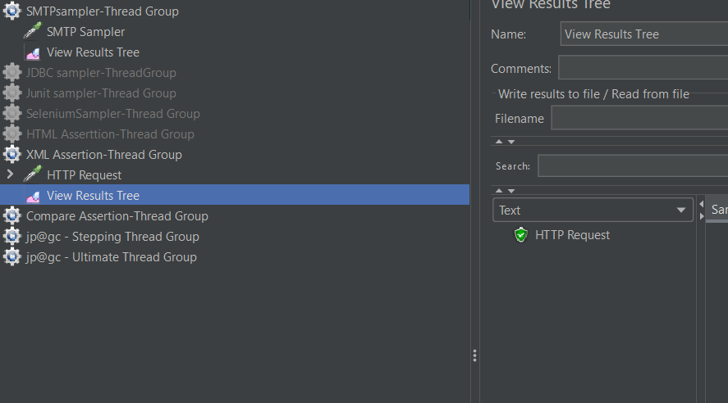

4.Write a program to demonstrate how a JDBC sampler script is run in JMeter.

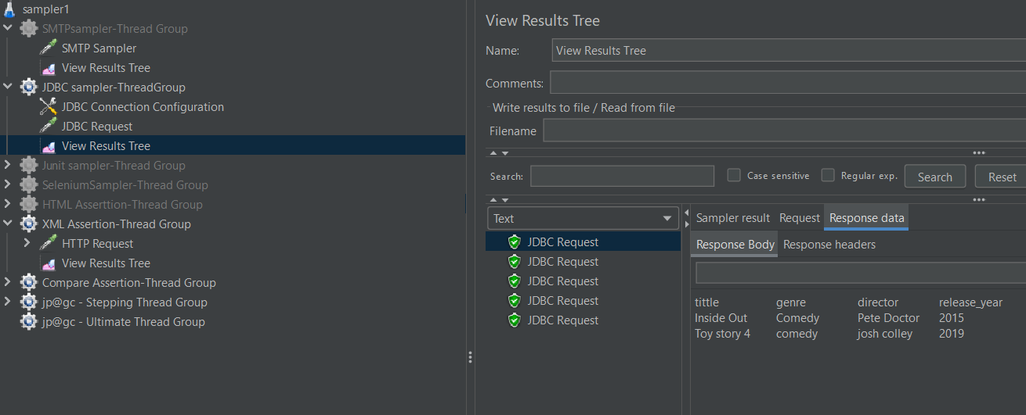

5. Write a program to demonstrate how a JUnit sampler script is run in JMeter

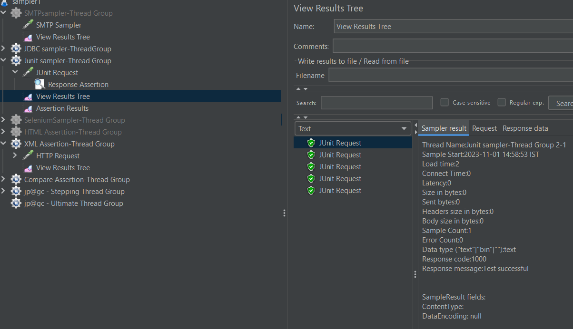

6. Write a program to demonstrate how Selenium WebDriver is integrated using JMeter script

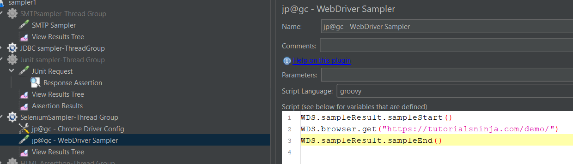

7. Write a program to demonstrate a WebDriver set sampler script in JMeter.

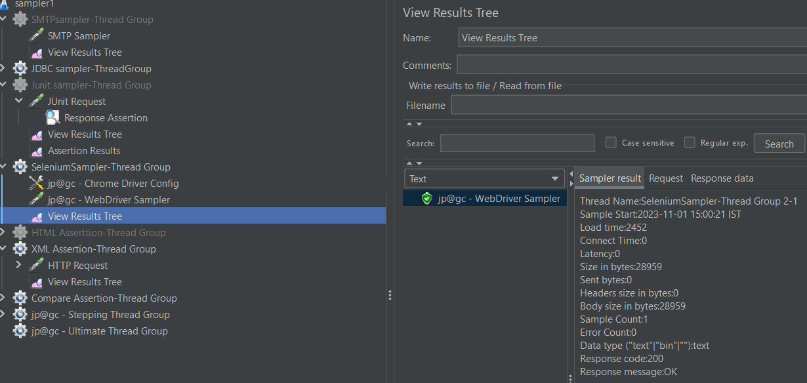

8. Demonstrate a FTP sampler in JMeter

